Hotel Plan

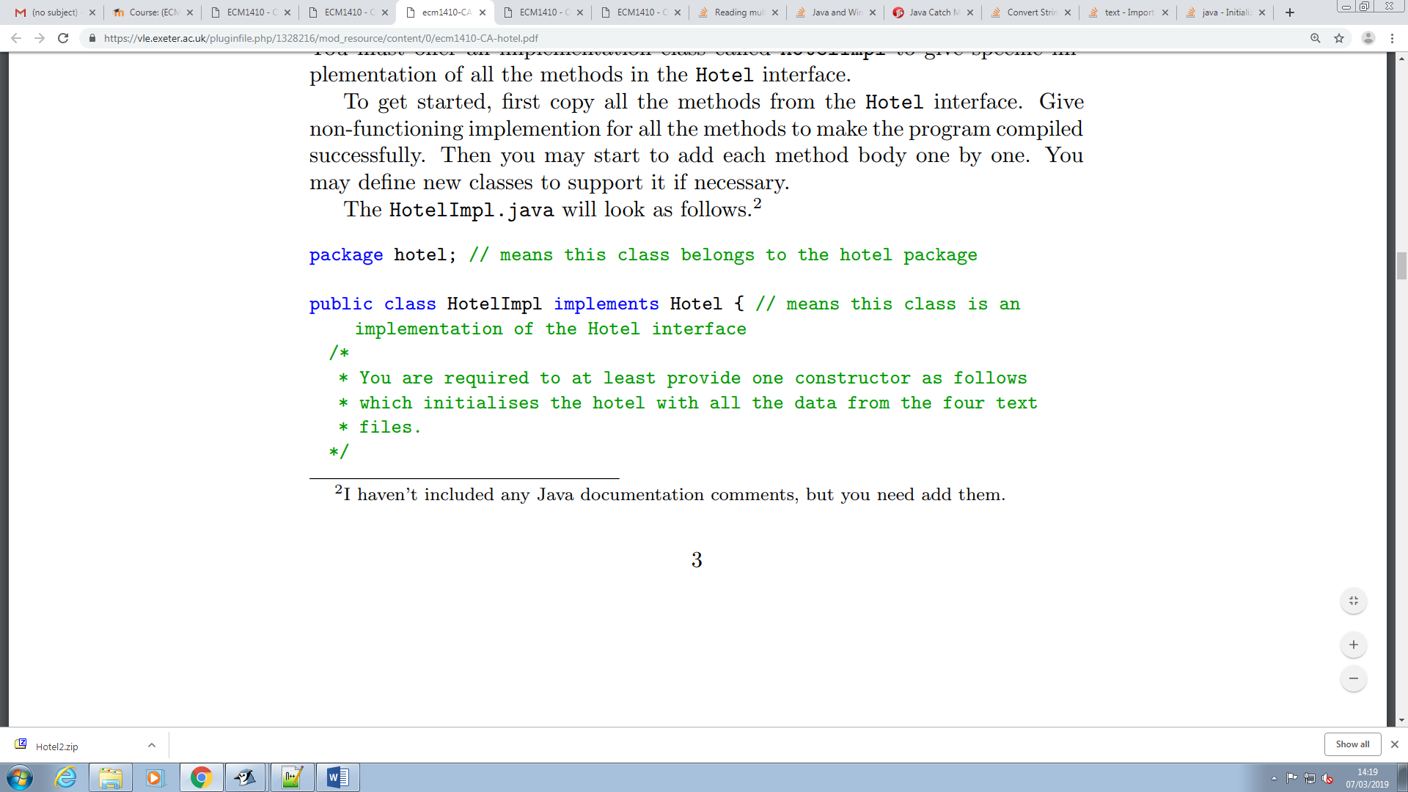

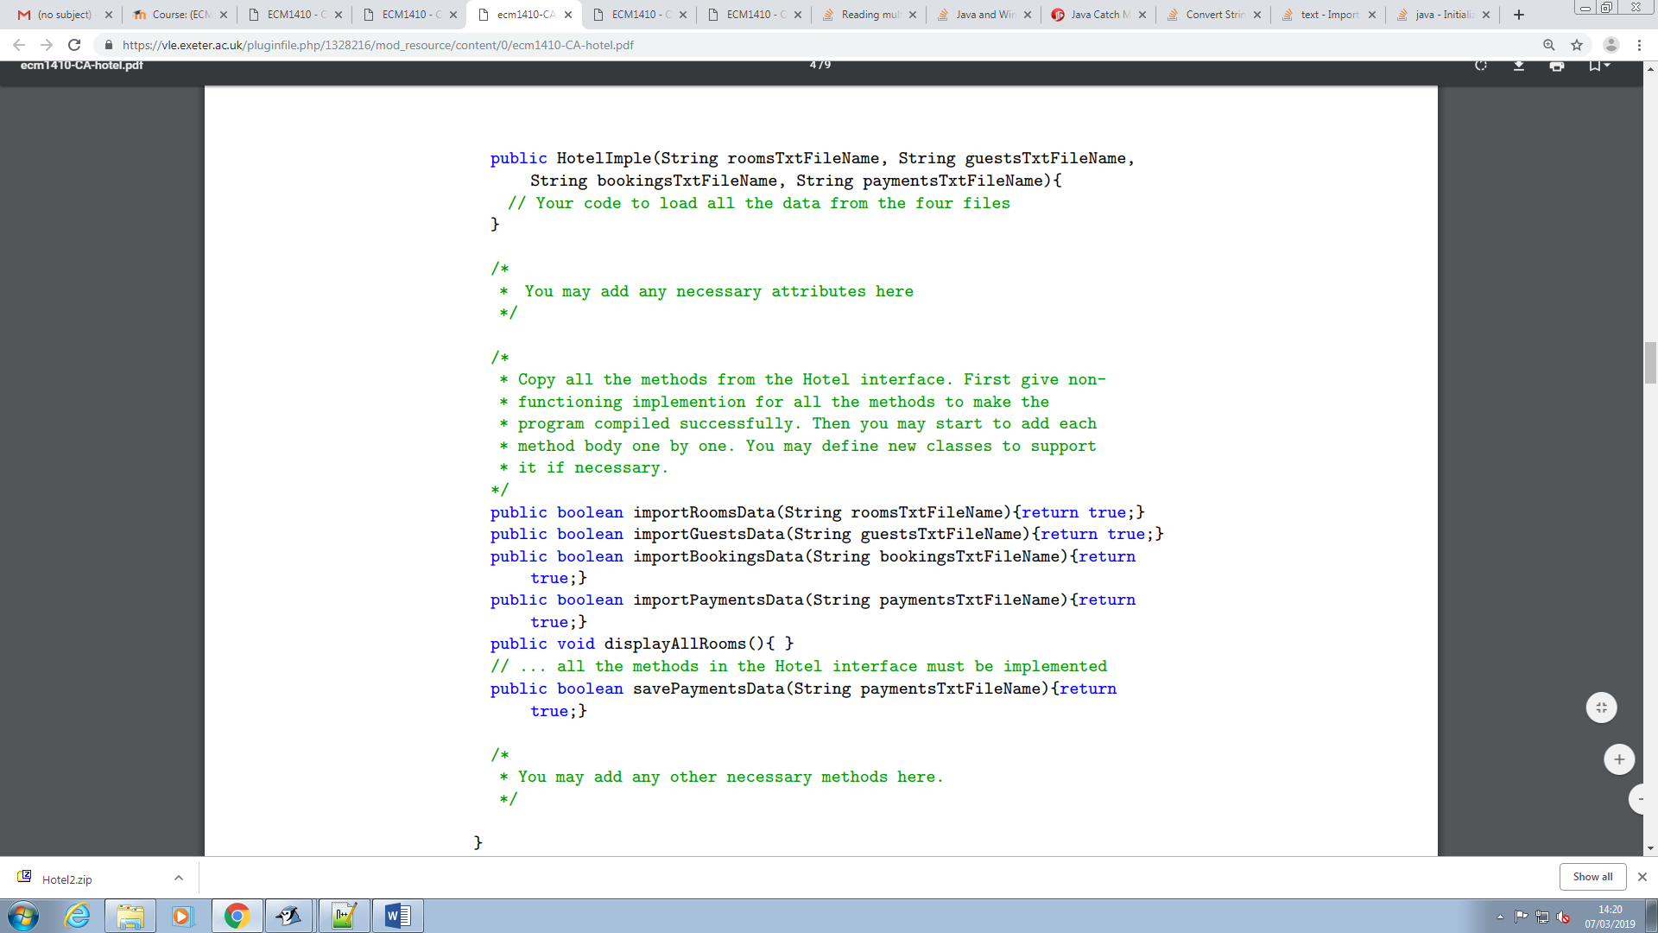

Constructor – loads in the data from the text files.

Methods – return a Boolean true or false value depending on whether the role of the method has been completed or not.

Go over Interfaces and implentations.